Title of the paper

Name and Surname of the first author^{*1A-E} (contribution), Name and Surname of the second author^{1A-E} (contribution)

Authors’ contribution:
- conception and design of the study
- acquisition of data
- analysis and interpretation of data
- manuscript preparation
- obtaining funding

¹Affiliation, city, country
²Affiliation, city, country
*Correspondence: Name and surname, and full address; email: xxx

Received: xxx
Accepted: xxx

Linked ORCID of each author: https://orcid.org/0000-0003-3844-550X

Abstract
An abstract shall be of 200-250 words.
Key words: Keyword 1, keyword 2, keyword 3, keyword 4, keyword 5

Subchapter
In text referencing you should use the APA style 7th Referencing System ie. (Sugden, 2010). When you quote an author please provide also a page number (Sugden, 2010, p. 5).
Xxx
Spell out acronyms in the first instance in the abstract and paper.

Next subchapter
For twentieth-century French sociologist Pierre Bourdieu,
“Quotation in italics” (Bourdieu, 2005, p. 39).

Ensure tables and figures are cited. Please provide titles and sources (if applicable) for all tables and figures. W prefer editable files e.g. Excel. Figures (JPEG, TIFF, PNG, BMP) should be sent as separate files if they contain photographs or drawings of good quality (high resolution.

Table 1. Title of the table (font 10 pts)
Category | Category | Category | Category | Category
Variable
Variable
Variable

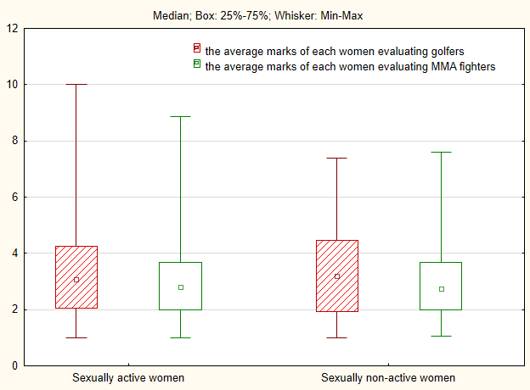
Note: name all abbreviations i.e. Min – minimum value
Figure 1. Title of the figure

Ethics approval and informed consent
Manuscripts reporting studies on human subjects, human data or tissue, or animals should include a statement on ethics approval and consent when humans are involved. Please include the name of the committee that approved the study and reference number if appropriate.

Competing interests
The author(s) of a paper submitted to Physical Culture and Sport. Studies and Research are required to complete a declaration of competing interest for any commercial associations or financial interests held by the author.

Funding
Please declare all the sources of funding including financial support. Please describe the role of the sponsor(s), if any, in any of the stages from study design to submission of the paper for publication.

Acknowledgments
All contributors who do not meet the criteria for authorship should be listed in the Acknowledgments section.

REFERENCES (APA style 7th Referencing System) – for details you may visit https://apastyle.apa.org/style-grammar-guidelines/references/examples

Bourdieu, P. (1978). Sport and social class. Social Science Information, 17(6), 819–840.
Bourdieu, P. (1984). A Social Critique of the Judgement of Taste. Translated by Richard Nice. Cambridge, MA: Harvard University Press.

